**Gemini Github Testrail Extension**

**Table of content**

Create and Copy a proper GIT branch name from Gemini Ticket title. 2

Quick Resource Assigning Panel 3

Make the side bar stay still when we scroll the page down. 4

Show Github pull request availabiliy 5

Bigger font size, different font type 6

Customized MCE editor 7

Due Date and Sprint Date 8

Button “Goto Gemini” on Github Pull Requests Page 9

Default Title on Open a Pull Request page 10

Toggle the “plus-signs” and the “minus-signs” on Github Compare page 11

Git-Fast Button 14

Open file in Visual Studio 15

The Options Page 16

Installation 17

# Create and Copy a proper GIT branch name from Gemini Ticket title.

Let’s say we have a ticket called: “BOA-13532 Just for walking though Gemini”.

GEMINI EXTENSION gets the ticket name “BOA-13532 Just for walking though Gemini”, turns it into “13532_Just_For_Walking_Though_Gemini” and puts that string into clipboard.

So you can just paste the branch name into SourceTree or Gitbash to create new branch.

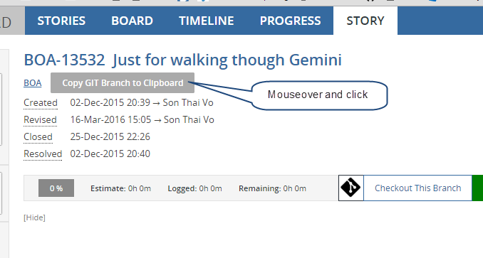

There is also a button to copy the title and the url, so that you can conveniently paste in your Skype or email.

The copied text might look like:

BOA-16867  Cash Receipts - Add the ability to produce a PDF cash receipt document for funds that were receipted previously

[*https://intranet.steadfasthub.com/AQGemini/workspace/0/item/16867*](https://intranet.steadfasthub.com/AQGemini/workspace/0/item/16867)

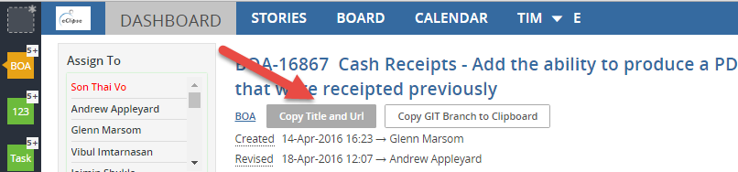

# Quick Resource Assigning Panel

It is probably faster than the combobox that Gemini natively has.

You just have to click on the person name and click Yes to confirm.

Why “click Yes to confirm”: Well, it is just to prevent you misclick a person.

The list of persons is sorted in order of relevance:

* First, current person
* Then, commentors
* Then, all the followers
* Finally, the rest of other persons (sorted by name)

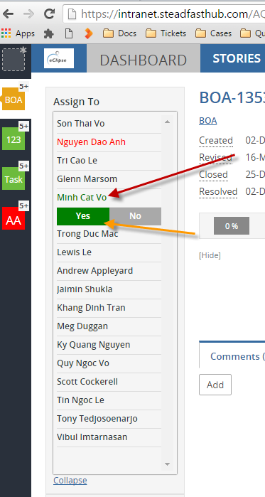

# Make the side bar stay still when we scroll the page down.

In case we have a ticket will a long description, or a lot of comment, the side bar will not be visible when we scroll down.

This will fix that problem.

One problem with this is that, if we don’t have a big screen, the side bar will have a scroll bar of itself.

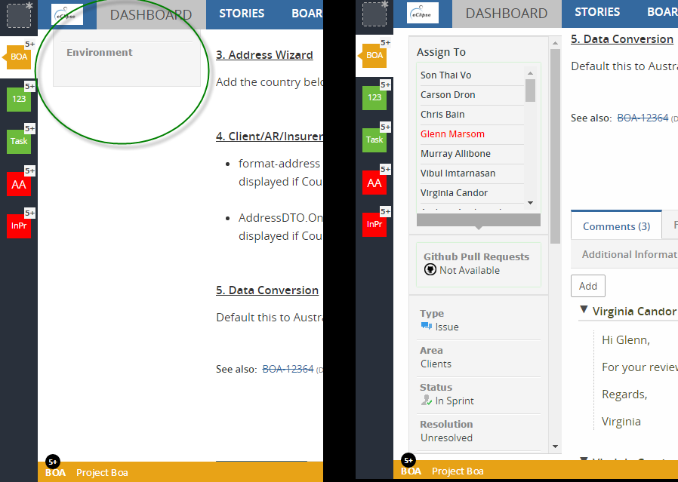

# Show Github pull request availabiliy

If a ticket has a corresponding PR, GEMINI EXTENSION will show a link to that PR.

Or “Not Available if there is no PR.

NOTE: Future version of the extension will show both open and closed PR, so that you can see the “code history” of current ticket.

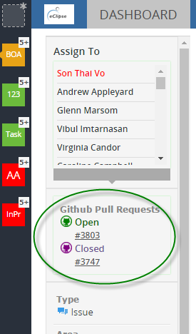 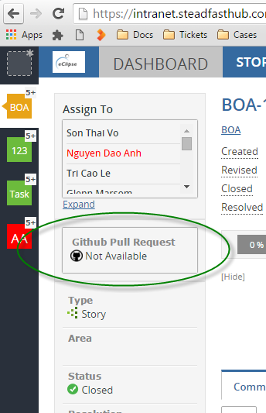

# Bigger font size, different font type

For some monitor, the text of Gemini looks quite small.

So, for better reading, the default font size and type of the ticket desciption and the comments are overridden by The Extension.

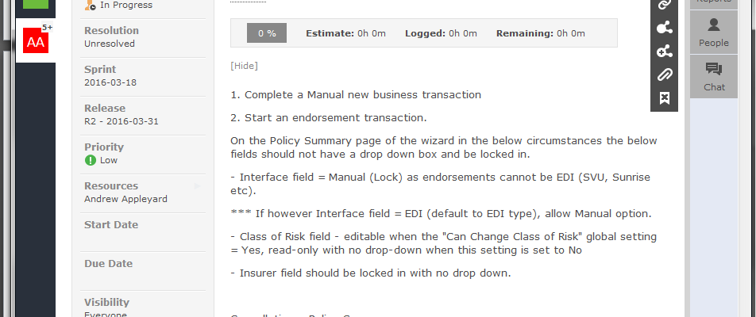

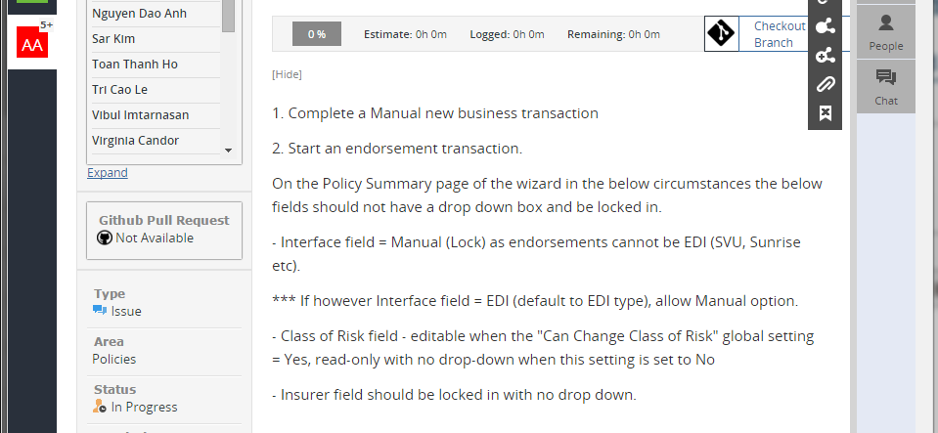

# Customized MCE editor

Some twists are made to the editor:

* A fullscreen button on the top right
* Different text size and font type.

NOTE:

The change of text size is actually done by the outer css, so…

You should not change the text size inside the editor, because if you do, the result text will appear as is, and the feature **“Bigger font size, different font type”** will not work;

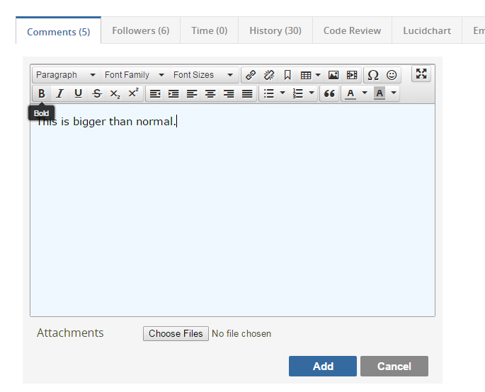

# Due Date and Sprint Date

(This feature is suggested by Lewis)

Usually when we create an issue, we want to set Due Date to be the same as Sprint date.

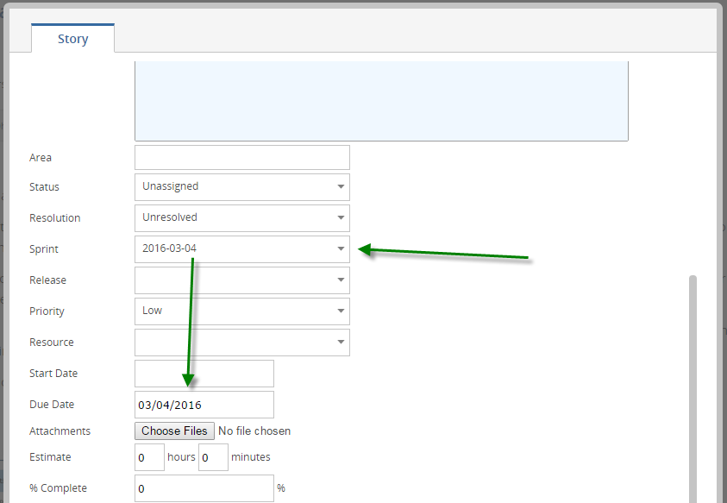

# Button “Goto Gemini” on Github Pull Requests Page

Introduce a button next to each PR, so that you can quickly go to the corresponding Gemini ticket.

**NOTE**: This requires the PR title to start with the Gemini ticket number, otherwise there will be no Gemini button.

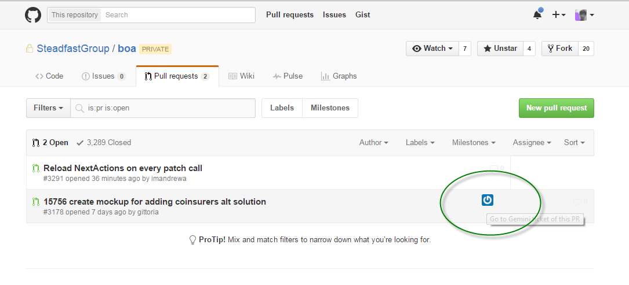

On the Pull Request Details page, there is also a similar button.

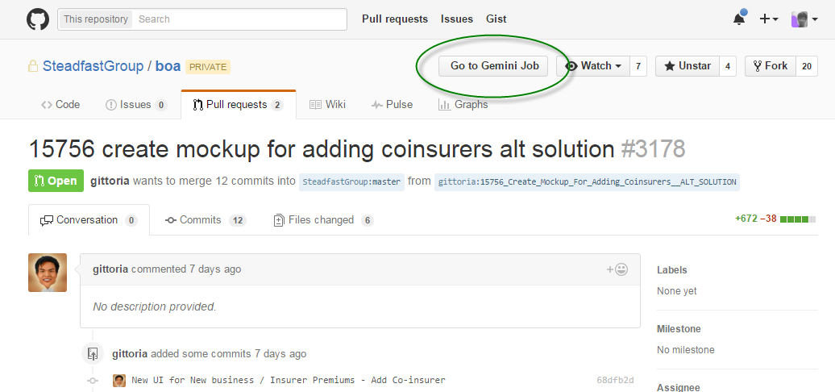

# Default Title on Open a Pull Request page

Gemini Extension will put the coresponding Gemini ticket name into the new Pull Request title textbox.

**NOTE**: Github saves the changes you made to the title and the comment of your new PR, so that you will not lose them when you reload the page. BUT this feature always set the PR title to the Gemini ticket name.

The Extension will override the changes you made, so be careful when composing a long title.

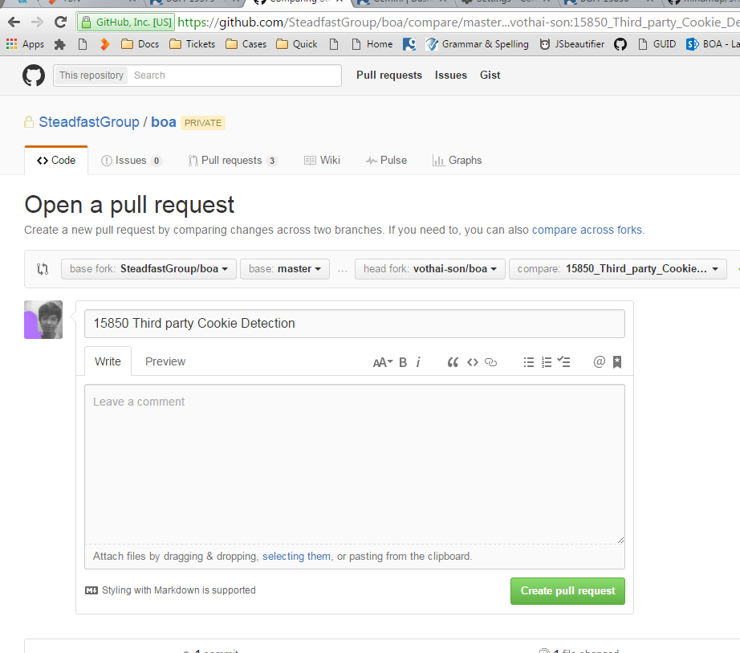

# Toggle the “plus-signs” and “minus-signs” on Github Comparison page

If you want to copy the code directly from there the diffs without the plus signs and minus signs sticking around your copied code.

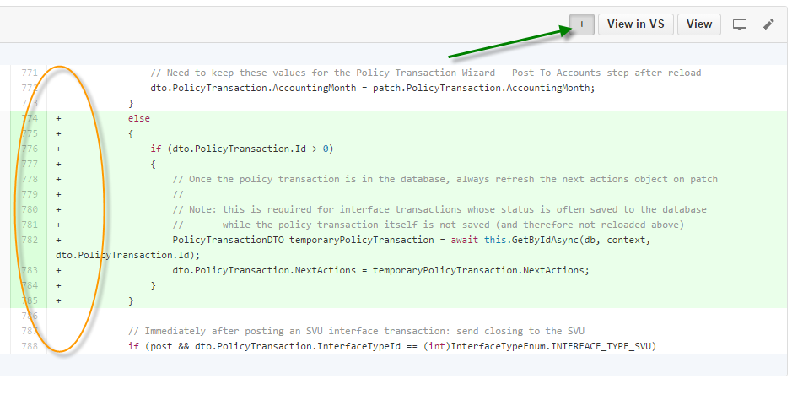

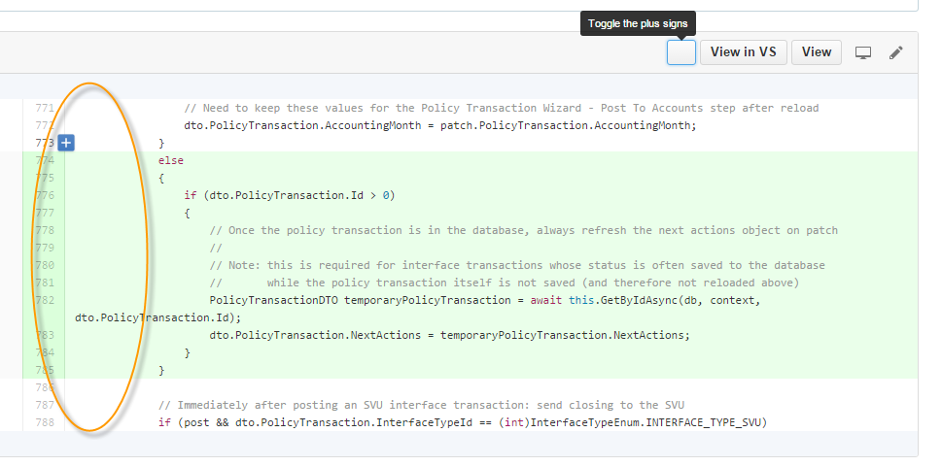

One hidden feature:

This will also help you avoid selecting both side of the diff when you drag you mouse to select a block of code.

Instead of this:

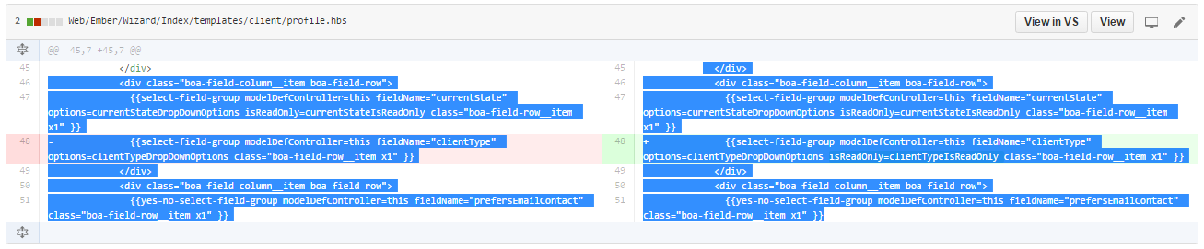

You have this:

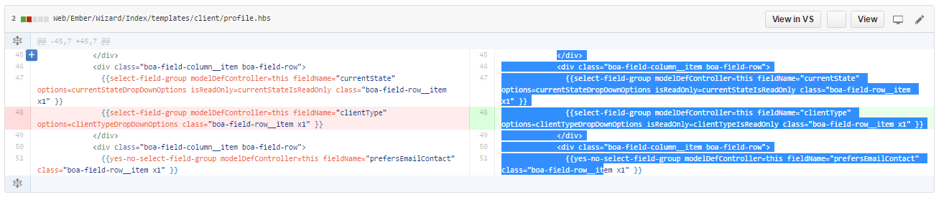

The next features require the Native Client to be installed on the machine.

(and properly configured)

# Git-Fast Button

Depend on the status of your local BOA git. GEMINI EXTENSION will suggest the appropriate git actions to you:

* Create git branch for current ticket
* Switch to the branch of current ticket (if such branch exists).

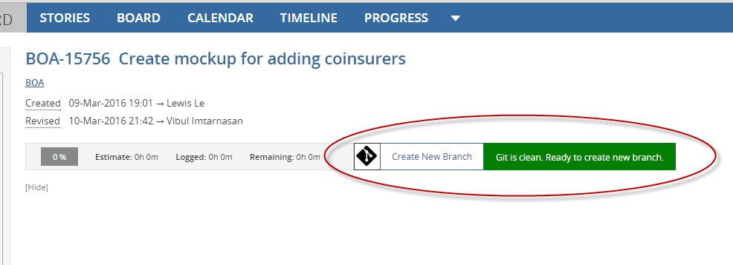

# Open file in Visual Studio

When you review your changes in a PR, a lot of times you have to go the file in BOA solution in Visual Studio to put in additional changes or undo some changes, or just add some comments.

This button helps you quickly go to the file at the line number you see on Github page.

(It might take one or two seconds to pop the file up in Visual Studio)

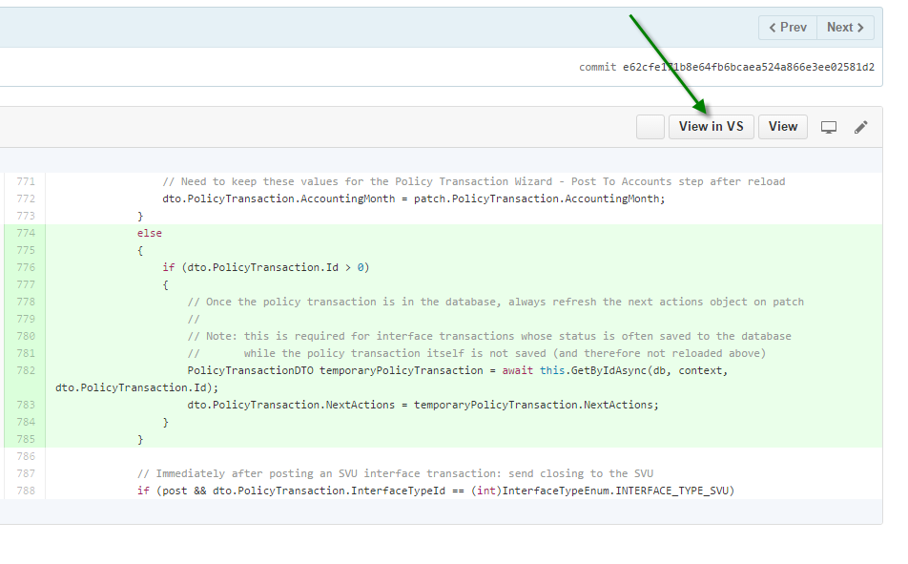

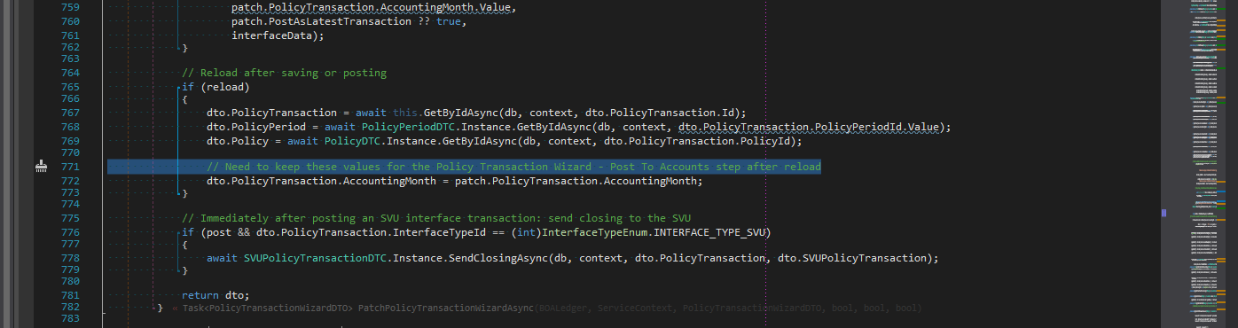

# The Options Page

All of the above features can be turned on or off in the Options Page.

To access this page, you can go to *chrome://extensions/* and click on the *Options* link of Gemini Extension.

Another way is to click on the Icon of GEMINI EXTENSION icon next to the URL bar of Google Chrome and choose OPTIONS.

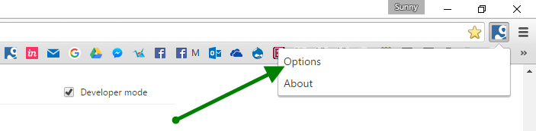

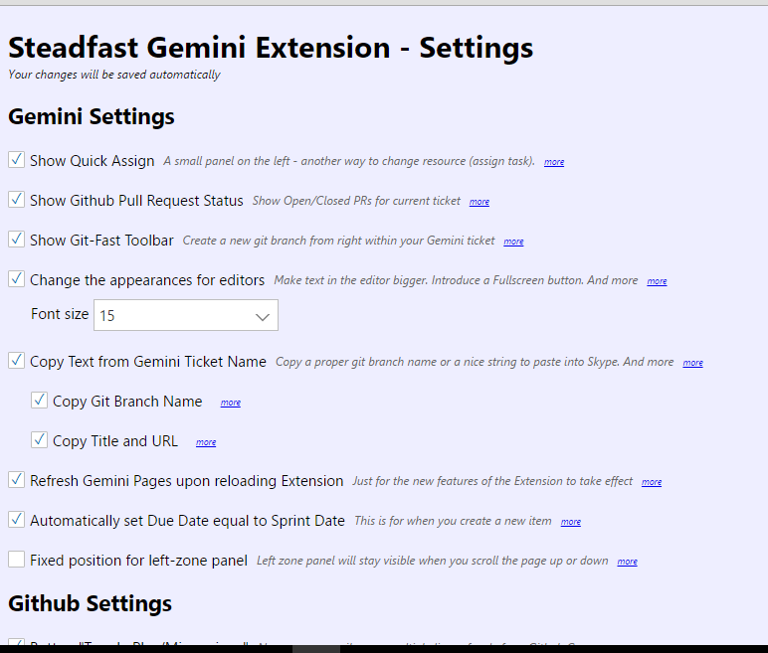

# Installation

1. Extract the zip file.

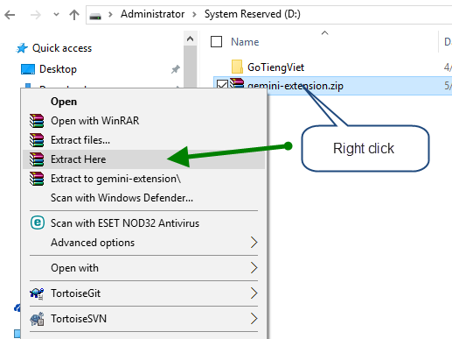

1. Go to Chrome://Extensions page, and check on “Developer Mode” checkbox

Then click the “Load unpacked extension…” button.

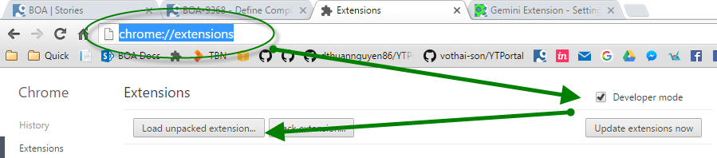

1. Paste the path of The Extension folder, and click OK.

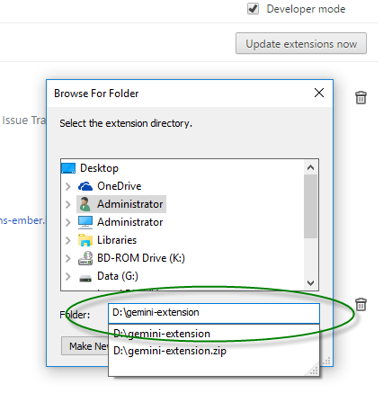

Done, The Extension is installed.